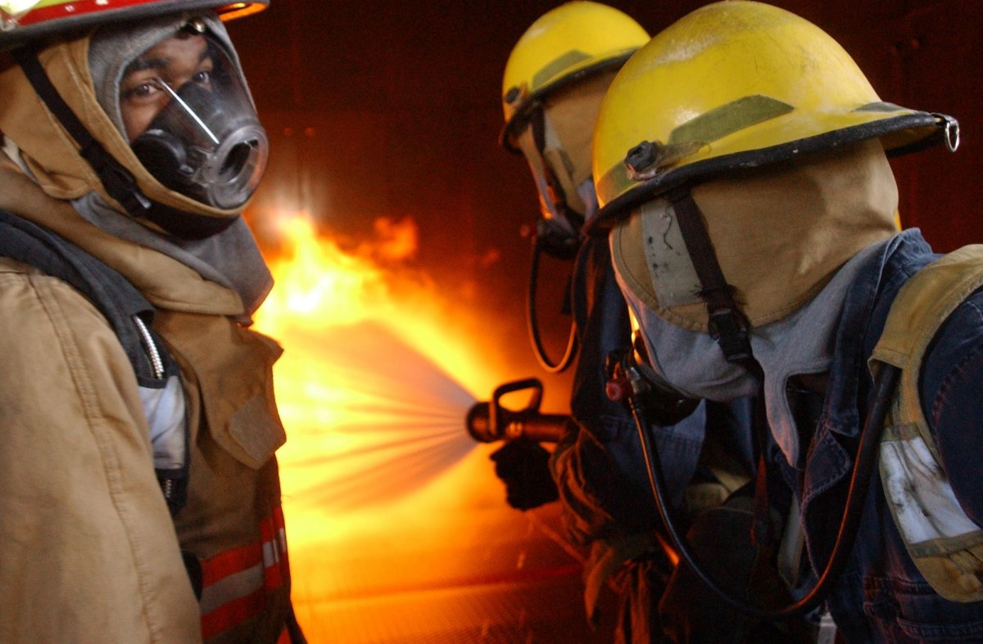  If at any time  you feel you require  assistance  or your fire  becomes  uncontrolled…  DO NOT HESITATE  DIAL 911  FOR ASSISTANCE |  |  | The Crofton Volunteer Fire Department is committed to your safety and the safety of the surrounding community. It is our mission to perpetually respond to fires for the purpose of saving lives and property.  When it comes to open burning, you play an integral role. Know the rules, follow the safety requirements, and make contacts.  croftonfireandrescue.com  Burn permits are issued under the authority of the Nebraska Revised Statute 81-520.01  Crofton Volunteer Fire Department |  |  | Crofton Volunteer Fire Department  - Open Burn Brochure

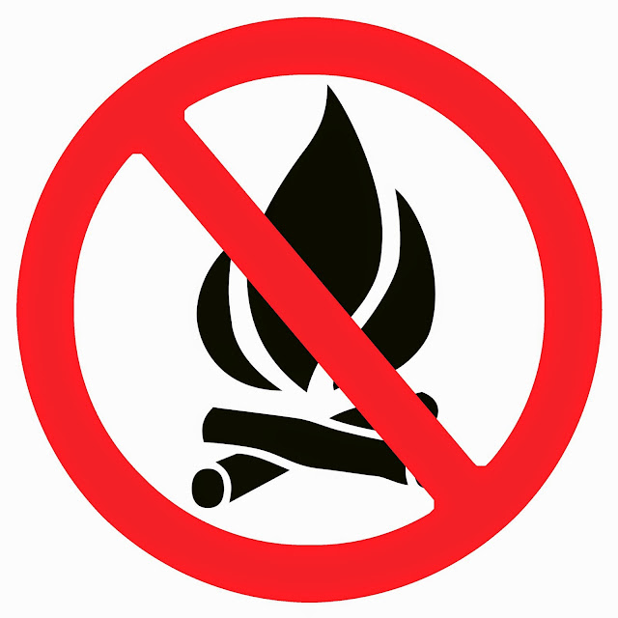  Burning of the following items is strictly prohibited:  - Tires  - Paint  - Asphalt products  - Roofing Materials  - Chemical Waste  - Rubber  - Coated Wire  - Plastic  - Combustible Cylinders  - Aerosol Cans  - Petroleum Based Products  - Asbestos containing products |  |  | Burn Permits are available at any time at our website croftonfireandrescue.com or M-Th during office hours from the following:  Michael Guenther Downtown Auto 605-660-3761  Bob Steffen Steffen Inc. 605-760-2162  Brett Luebbe By Appointment Only 402-380-8294  Applicant must be the registered property owner or an authorized agent of the property owner in writing to obtain a permit.  Once issued, a permit is in effect for three (3) calendar days including the day issued. (If a permit is issued on the first of the month, it is good until dusk on the 3rd of the month). |  |  | Burning material is prohibited within 50ft of a structure including power poles, power lines, etc.  Means of extinguishment must be available and ready to use at all times that the fire is active.  Fire must always be attended by a responsible person at least 18 years of age.  Fires must be extinguished by dusk, no burning through the night.  Burn permits may be revoked if the smoke is causing an offense to neighbors near the fire, weather conditions change creating possible hazards or smoke blowing across a road or highway creates a hazard.  Burning will not be allowed with wind speeds greater than 12mph or a relative humidity less than 35 percent as determined by the National Weather Service.  No burning will be allowed at any time there is a fire ban in place (statewide or regionally)  .

